User Data Backup
In this use case, we backup user’s data and save it on the edge server. Ten percent of the edge server resources will be used to save these data. The major point is saving user data and use it when needed, so we will use memento pattern to implement this use case.
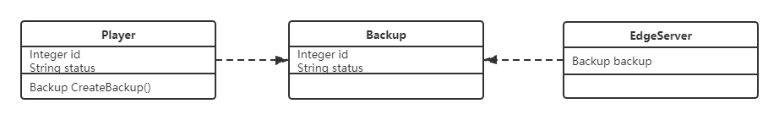
Player class has some values that need to backup and there is a function which is used to create a Backup class to save values. EdgeServer class is used to save the memento class.

Player Class

public class Player {

private Integer id;
private String status;

public Integer getId(){
return id;
}

public String getStatus() {
return status;
}

public void setId(Integer id) {
this.id = id;
}

public void setStatus(String status) {
this.status = status;
}

public Player(Integer id, String status) {
this.id = id;
this.status = status;
}

public Backup createBackup(){
return new Backup(id, status);
}

public void restoreBackup(Backup backup){
this.id = backup.getId();
this.status = backup.getStatus();
}
}

Backup class

public class Backup {

private Integer id;
private String status;

public Integer getId(){
return id;
}

public String getStatus() {
return status;
}

public void setId(Integer id) {
this.id = id;
}

public void setStatus(String status) {
this.status = status;
}

public Backup (Integer id, String status) {
this.id = id;
this.status = status;
}
}

EdgeServer class

public class EdgeServer {

private Backup backup;

public EdgeServer(Backup backup) {
this.backup = backup;
}

public Backup getBackup() {
return backup;
}

public void setBackup(Backup backup) {
this.backup = backup;
}
}

Dealing data
This use case focuses on receiving data from players and transfer received data to game server and let game server deal with it, then game server send data to client server. Finally, client server runs the treated data. This use case will be using command pattern. The advantage of using this pattern is that the classes which are in this process are decoupled from each other. These classes just have to do their own job.
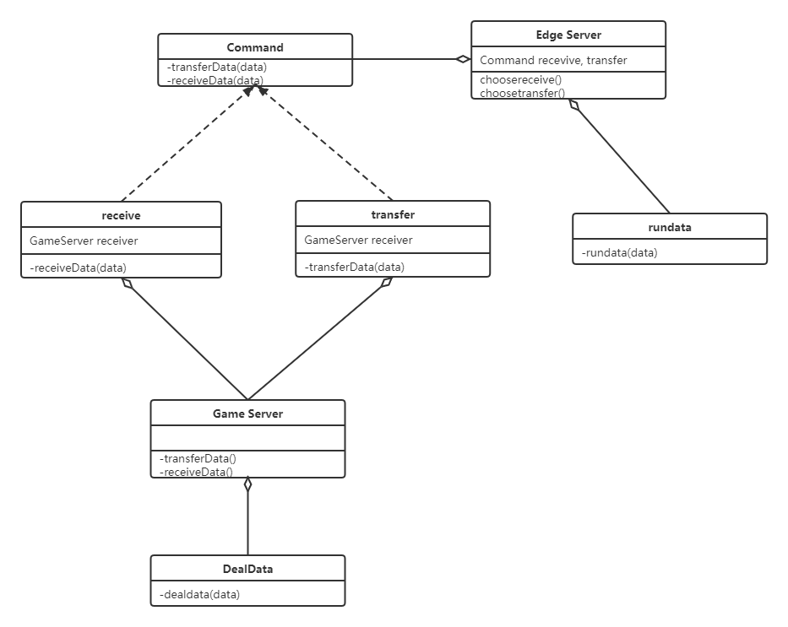
Command is an abstract interface.

public interface Command {
public void transferData(data);
public void receiveData(data);
}

public class transfer implements Command {

private GameServer receiver;

public transfer(GameServer receiver) {
this.receiver = receiver;
}

@Override
public void transferData(data) {
receiver.action();
}
}

public class receive implements Command {

private GameServer receiver;

public receive(Player receiver) {
this.receiver = receiver;
}

@Override
public void receiveData(data) {
receiver.action();
}
}

public class GameServer {

private Command command;

public GameServer(Command command) {
this.command = command;
}

public void action(){
command.transferData(data);
command.receiveData(data);
}
}

public interface dealdata(data) {
public void dealdata(data);
}

public interface rundata(data) {
public void rundata(data);
}

